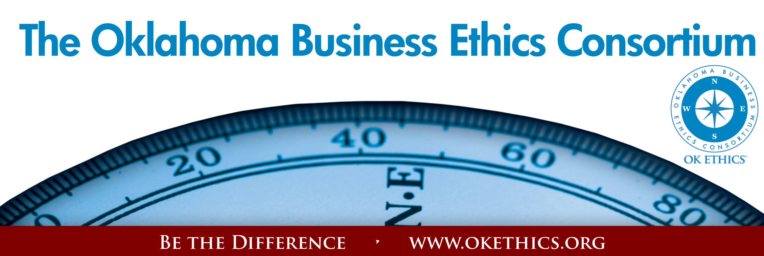

Agenda ~ Oklahoma City Chapter
December 10, 2008

- WELCOME Todd Lisle, BKD, Inc.
OK Ethics Board of Directors
Welcome to our table sponsors:
- The Busey Group
- Southern Plains Medical Group
- OBU International

II. GUIDING PRINCIPLE: COLLABORATION
- Achievement of common goals through the promotion of ethical, mutually beneficial relationships
- Service to the Consortium over promotion of self-interest
- Cooperation emphasized over competition in promoting ethical business conduct
- Members collaborate by being constructively engaged in discussions regarding ethics
- Seeking consensus in interactive discussions regarding ethical matters.

III. KUDOS
“Feeling gratitude and not expressing it is like wrapping a present and not giving it.”
- William Arthur Ward
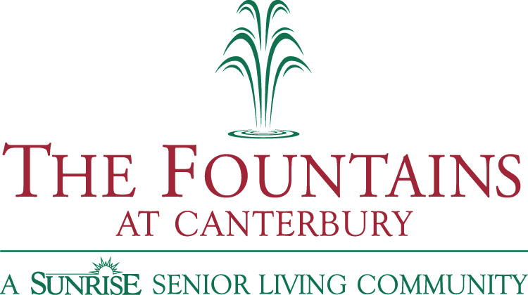
A special acknowledgement to The Fountains at Canterbury for
co-sponsoring this event, marketing it to the area hospitals and providing CEU’s for social workers.

Registration Team:
- Greg Byers of Sinclair Broadcasting Group – Registration Chair.
- Mary Kay Huggard & the Principal Technologies team, including
Lisa Laughlin, Kara Argo, Lindsey Munyon, and Ashley Warne.
- Deborah Gavula – OK Ethics Administrative Support

Name tags:
- Joshua Jantz - Institute of Basic Life Principles

Handouts:
- Linda Manaugh - Metro Technology Centers

Pre-meeting Slideshow & Webmaster
- Connie Barwick – Maximum Multi Media Creations

Directions Commemorative Publication:
- Kelli Schneider – Full Force Marketing & Brand Development

Speaker Gifts
- Alisa Hall – The Stiletto Advantage
- Tess Smith – Walker Companies

We appreciate all of our dedicated volunteers who serve on the Board and are the heart of this organization!

IV. DISCUSSION QUESTIONS Shannon Warren, Founder, OK Ethics
Health care is a hot topic these days. According to a guest column written by OK Ethics member Phil Busey and published in The Journal Record, Oklahoma has more than 600,000 uninsured people. What are the ethical ramifications of that issue in our state and country? Is health care an entitlement? Who should pay for care? In times of corporate layoffs, what is the ethical obligation of business for the health care of its workers?

- KEYNOTE
“Healthy Ethics: Hospital Execs Discuss Diagnosis and Treatment of Ethical Dilemmas”
Cathryn Hibbs  CEO  Deaconess Hospital | James Moore  President  INTEGRIS Canadian Valley Regional Hospital | Garyl Geist  President & CEO  Valir Health | Tom Rice  President  Southern Plains Medical Group

VI. UPCOMING EVENTS Shannon Warren, Founder, OkEthics
Advance reservations required for all events ~
Visit our website at www.okethics.org or call 858-2233;
Member discounts apply regardless of location.

Oklahoma City Chapter:

PROGRAMS RECOMMENDED FOR 1 CPE IN ETHICS:

January 14
“Generational Differences in Ethical Decision-Making”
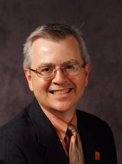 | 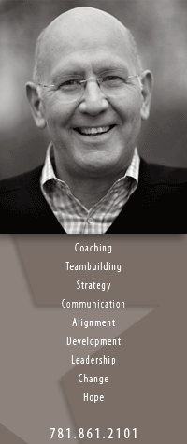
Dr. Ken Eastman, Oklahoma State University | Dr. Harry Hutson, Devon Energy

February 11
“Good Ethics for Bad Times”

What lessons have we learned about ethics from past recessions?
Examining periods of economic recession and the impact these have had on organizations in the past, Donna Miller of Executive Resource Center, LLC will facilitate an interactive program designed to help strengthen ethical decision-making skills and insights required for tough times.

Highlights include: Identifying Unique Ethical Risks During Bad Times • Communicating The Typical Warning Signs And Reasons For Bad Behavior • Learn The Reasons Why Employees Do Not Stop Or Report Bad Behavior • Staying out of Ethical Debt

Part of the program will be based on the popular Price Pritchett model of "The Excellence of Ethics".

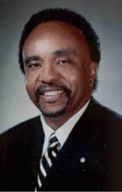
March 11
Clifton Taulbert, President of The Building Community Institute
Taulbert is one of America's leading thought-leaders on the "Power of Community" and views community in the workplace as a powerful leadership asset. Taulbert was chosen by CNN at the turn of the millennium to represent one of the voices of 'Community.' Taulbert, a Pulitzer nominated author speaks throughout the world on the critical issue of building community, a set of emotionally satisfying relationships, within all the places of our living...creating an environment branded by Respect, Affirmation and Inclusion.
Taulbert is also the author of the internationally acclaimed book, Eight Habits of the Heart, a book that provides the framework on which to build, maintain and sustain a powerful, effective and caring Community. He believes the Eight Habits of the Heart are essential for developing leadership and he conveys this message to audiences around the world.
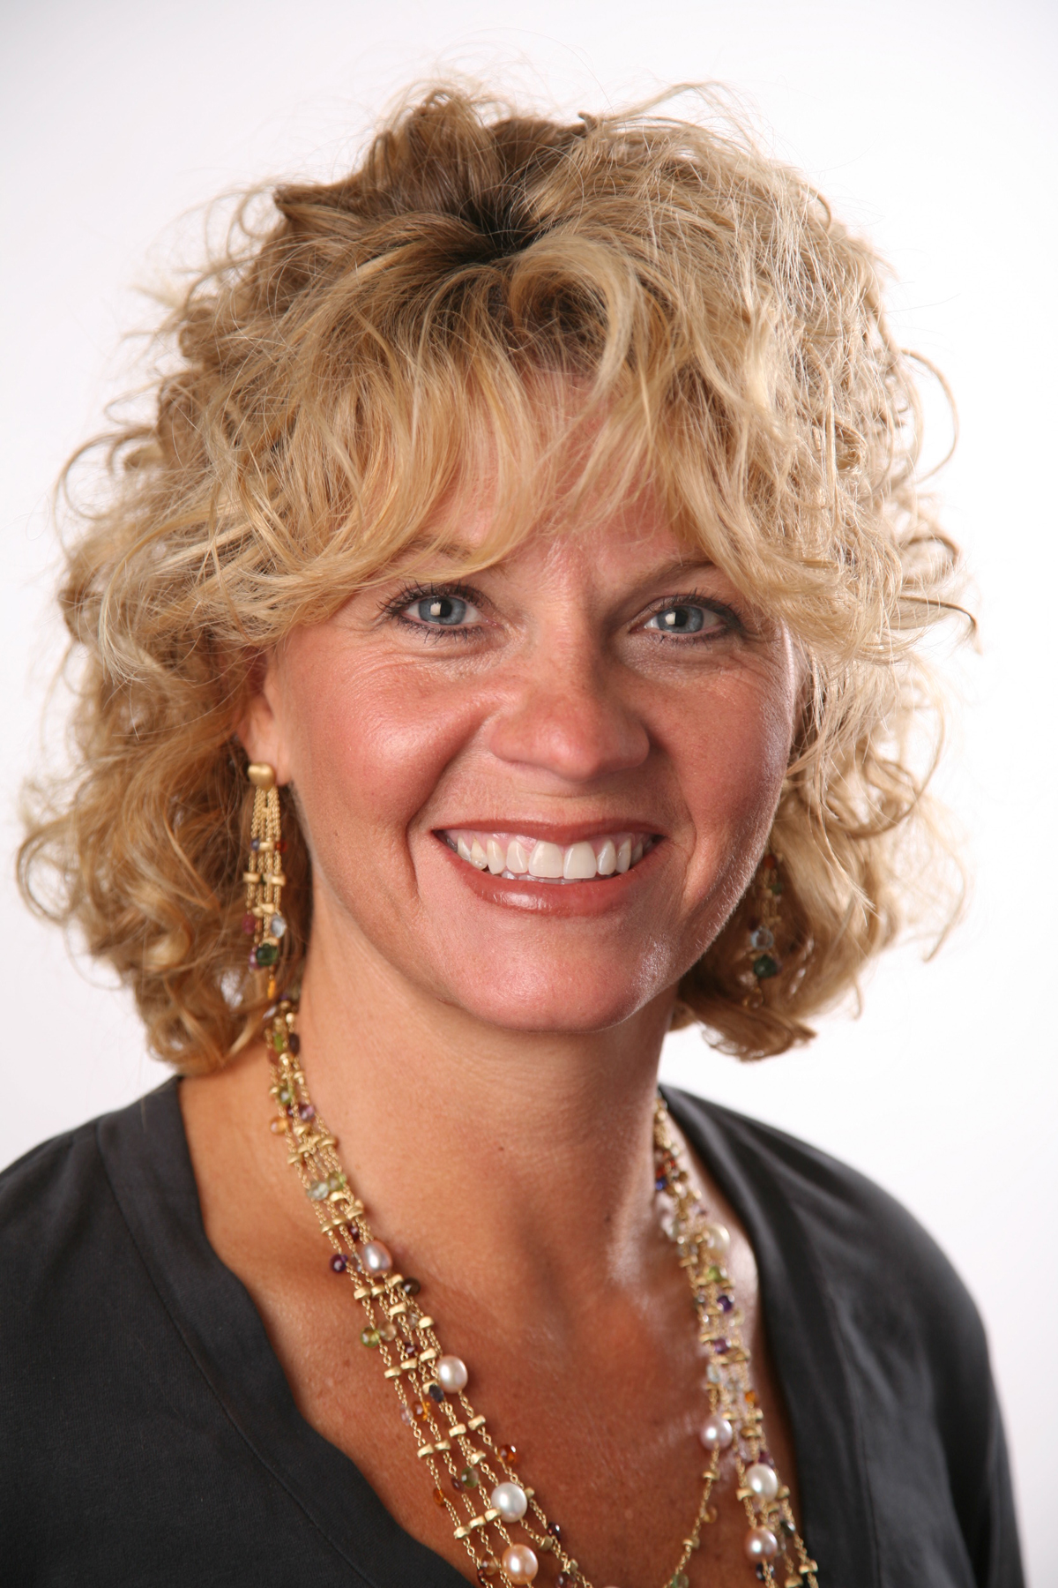

April 29 – OU Coach, Sherri Coale –
OK Ethics Statewide Compass Awards (OKC)

Tulsa Chapter
December 11 – Steve Burrage, State Auditor & Inspector

- OTHER RELATED PROGRAMS:

OK Ethics is honored by our friendship with the Character First! Institute. They provided wisdom and the basis for our Guiding Principles. For more information on their upcoming Oklahoma City Business and Community Leaders' Luncheon, please contact them at 815-0001, or visit www.characterok.org./

Orderliness in the Workplace
Dates:
Breakfast - Tuesday, Dec. 16, 2008—7 to 8 A.M. -RSVP Required by Dec. 12
Luncheon - Thursday, Dec. 18, 2008—12 to 1 P.M. -RSVP Required by Dec. 15
Cost: $10
Location:
520 West Main Street
Downtown Oklahoma City
For more events and information about OkEthics, please visit our website at www.okethics.org
See also additional sponsors listed on our website.

CPE’S & CEU’S WILL BE ISSUED AT THE BACK OF THE ROOM
AT THE CONCLUSION OF THIS EVENT

YOU MUST SIGN YOUR NAME TO RECEIVE A CERTIFICATE
NOTE THAT WE WILL NOT EMAIL THESE
PLEASE HELP US CONTROL COSTS BY LEAVING YOUR NAME TAG HERE!

